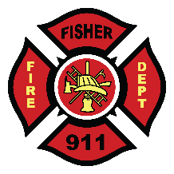

RM OF FISHER FIRE DEPARTMENT
Application for Volunteer Membership

Name: Present Address: Phone Number:

What experiences, skills or qualifications do you feel you have that would assist our fire department?

If accepted, do you have reliable means of transportation to get to the Firehall?

Do you have any illnesses or disabilities that we should be aware of?
e.g. Claustrophobia, asthma, heart disease, etc.

Signed

Date

Parents signature (if required)

Although attendance at every call is not expected due to life circumstances, an expectation of attendance is understood.

